

IoT Solution Specification

**Team:** iFarmers (Group 5)

**Team members:**

Duan Yuzhong z5174781

Negar Bolourchi z5160635

Sebastian Castillo Castro z5171921

Sudhan Maharjan z5196539

Timothy Yeo z5162103

Xin Zhang z5197887

**Table of Contents**

**IoT Strategy** **2**

**Business Motivation** **2**

Business Motivation Model 2

**IoT Opportunity Management** **3**

IoT Opportunity Portfolio 3

Value Proposition Design 9

Value Network 11

**IoT Capability Management** **12**

Business Capability Model 12

Technology Capability Model 13

**IoT Technology Strategy** **14**

**IoT Strategic Roadmap** **21**

**Business Value Management** **22**

Balanced Score Card 22

**IoT Architecture** **25**

**IoT Solution Design** **43**

# 

# **IoT Strategy**

## Business Motivation

### Business Motivation Model

**Vision:**

iFarmer, well known for improving people’s lives, aims to provide futuristic, sustainable solutions and services in order to positively impact the wind energy industry.

**Mission:**

Use IoT technologies to improve reliability and longevity of wind power assets.

**Goals:**

* To use IoT technology to provide appropriate predictions on performance and failures of the wind power assets.
* To reduce downtime of wind turbines

**Objectives:**

* Improve prediction of failures by 30% in two years
* Improve overall performance of wind power assets in 6 months of installation
* Reduce maintenance visits to farm sites by 50% within two years
* Reduce downtime period by 20% in two years

## 

## 

## IoT Opportunity Management

### IoT Opportunity Portfolio

|  |  |  |
| --- | --- | --- |
| Opportunity name | Description | Associated objective |
| Wind turbine compensation. | Downtime of turbines could cost the contract that a site has with an energy provider. Through the monitoring of all turbines in a farm, we can compensate the downtime of particular turbines with other turbines. | Improve overall performance of wind power assets.  Reduce overall downtime of the wind farm. |
| Turbine and wind orientation monitoring. | Localised systems within a turbine are used to ensure that the turbine is aligned properly with the wind. Tracking that the system is working with sensors, i.e. checking alignment optimal performance is obtained. | Improve overall performance of wind power assets.  Ensures reliability in localised systems and real time feedback of orientation of wind turbines. |
| Fault prediction in wind turbine through heat and vibration monitoring | Gearboxes are one of the most likely components within a turbine to break. Through the monitoring the heat and vibration of a gearbox, we can predict whether a gearbox will break. | Improve predictions analysis of failures. |

**Opportunity 1: Wind farm compensation**

**Desirability:**

**Site supervisor:**

This persona needs to maintain a quota. Take for example if the site supervisor needs to ensure that wind turbines are running 90% - 95% every 4 months. As long as the quota is reached at the beginning of the quarter, nearing the end of this period is not as much of a worry for damaged turbines. Hence when an asset is in its downtime, in good condition turbines can continue to run to compensate.

Damages and additional costs from compensating underperforming turbines can be manageable as long as the contract is maintained. However, managing the risk of making good condition turbines continue working may put the asset in danger of damage.

**Customer’s Journey**

|  |  |  |
| --- | --- | --- |
| Awareness | Consideration | Decision |
| I need to meet this quarter’s quota to maintain my contract with energy providers | What do I need to optimise underperforming assets in the farm?  I need to know how much risk there is in making another turbine compensate for underperforming assets. WIll this technology cost a lot? | Increase usage of optimal condition turbines because risk of damaging these assets is not detrimental as violating their contract. |

**Feasibility:**

The feasibility of this solution is quite low. Fundamentally this idea is to make wind turbines that are in good condition continue to work longer in order to compensate for underperforming assets that are in down time. Attempting to grade the conditions of the turbines with just sensors would be too difficult as there would be too many factors to consider. The balance of risk is also a factor. Wind turbines are scheduled for maintenance every few months. Pushing back on scheduled maintenance poses a potential risk if we were to keep them to compensate for the overall quota.

**Capability Gap Assessment**

|  |  |  |  |
| --- | --- | --- | --- |
| Current State | Desired State | Gap Identified | Corrective Actions |
| Have enough money to afford sensors that track underperforming turbines | Able to make predictive decisions in order to automatically compensate underperforming assets with better performing turbines | Understanding what risks are involved with making a wind turbine work for longer.  Lack meaningful data to use for create predictive models | Receive data for how to optimise output of energy from turbines. Understand  limitations of a turbine’s internal parts |

**Viability:**

Due to the size of the company, it would be difficult to look into a large range of factors that contribute to the condition of a turbine. In order to give sound advice as to whether or not a turbine is in good condition, there is a limitation in what conclusions can be made as we can only track certain data with sensors.

**Opportunity 2: Turbine and wind orientation monitoring**

**Desirability:**

**Engineering Analyst:**

One of the roles of this persona is to track how assets are performing. Within a wind turbine, there are local control systems to rotate the turbine to certain angles according to wind orientation. With IoT, we will be able to help track the reliability of this system and send real time data of the angle of the turbine against the wind to the engineering analyst.

**Customer’s Journey**

|  |  |  |
| --- | --- | --- |
| Awareness | Consideration | Decision |
| I need to make sure my systems are doing their jobs  I need to track how wind turbines are performing. | What systems should I be monitoring?  What factors lead to an efficient turbine? | Utilise gained data from sensors to determine whether turbine orientation is aligned with the wind direction. This ensures that localised systems for moving the turbines is working |

**Feasibility:**

The level of complexity of this solution is manageable. If the turbine orientation does not match the recommended position in correlation to the wind direction, then an alarm will trigger to inform the engineer analyst.

**Capability Gap Assessment**

|  |  |  |  |
| --- | --- | --- | --- |
| Current State | Desired State | Gap Identified | Corrective Actions |
| No system developed to monitor this feature  Able to afford the sensors | Have a dashboard that informs analysts in a centralised way the current orientation of each turbine in the farm. | Need to develop a dashboard.  Implementation of sensors.  Development of system  Implement a real time alerting mechanism. | To develop each system.  To find the ideal position for sensors. |

**Viability:**

The viability of this product is low due to the local system that maintains the optimal orientation of the turbines, rarely fails. Therefore this product does not provide favourable value into the condition of the turbine for the customer.

**Opportunity 3: Industry Challenge**

**Desirability:**

**Site Supervisor:**

More than just managing contracts for services, a site supervisor needs to manage contracts with repairs. If there is a major failure within a turbine, one of the major expenses, other than gathering new parts, is to hire a crane. Due to needing to hire a giant crane, costs can go up to $100,000 AUD for setup and another few thousands per hour for usage. It is in the best interest of a site supervisor not only to prevent failure however if failure is inevitable, what he/she could do is preemptively hire a crane in advance to fix whatever problems the turbines are having. Setup and usage fee can be negotiated to save up to 30% of costs and several turbines can be scheduled to be fixed up at the one time. We propose that through the monitoring of the heat and vibration of the turbine’s gearbox, we will be able to make predictions up to 3 weeks in advance to give the site leader time to figure out whether the gearbox requires additional attention or to book a crane.

**Customer’s Journey**

|  |  |  |
| --- | --- | --- |
| Awareness | Consideration | Decision |
| I need to have better ways to find faults in my turbines because it is costing a lot to hire cranes to repair them. | What are factors that I can look at to predict when an asset might break? | Adopt sensors that gather data that lead to alerts of when turbines will fail in the foreseeable future.  Use predictive analysis data in order to make informed decisions of whether something needs more attention. |

**Feasibility:**

The level of complexity of this solution is possible. Heat itself is already an indication of when lubricate oil in the gearbox loses its effectiveness. With the loss of effectiveness of the oil, friction will increase the chance of the gearbox breaking. Positioning and gathering data from the gearbox is straightforward and non-invasive. Alone, heat can give a 3 day indicator of potentially what could go wrong in a gearbox. With vibration, it can give 2-3 weeks indication of fault detection however, vibration is hard to read. Within an average vibration reading, a lot of noise will be found. It will take experts to decipher what is usable in that reading.

**Capability Gap Assessment**

|  |  |  |  |
| --- | --- | --- | --- |
| Current State | Desired State | Gap Identified | Corrective Actions |
| No system developed to monitor gearbox temperature and vibrations.  Can afford sensors. | Able to make predictive analysis and assemble relevant data on a dashboard | Need to develop a dashboard  Implementation of sensors  Development of system  Needing the thresholds of when vibration and heat is an indicator for potential faults | To develop each system.  To find the ideal position for sensors.  Research thresholds. |

**Viability:**

This solution is definitely viable. As stated above, there is a definite need for a reliable way to predict faults in a wind turbine. Not only is fault detection used for preventing assets from breaking but for future repairing plans. Vibration is another facet that we could explore. Although it is difficult to achieve meaningful data from a vibration reading, the potential of having fault detection 2-3 week ahead could save up to $30,000 per crane hire.

### 

### *Fig.*

### 

### Value Proposition Design

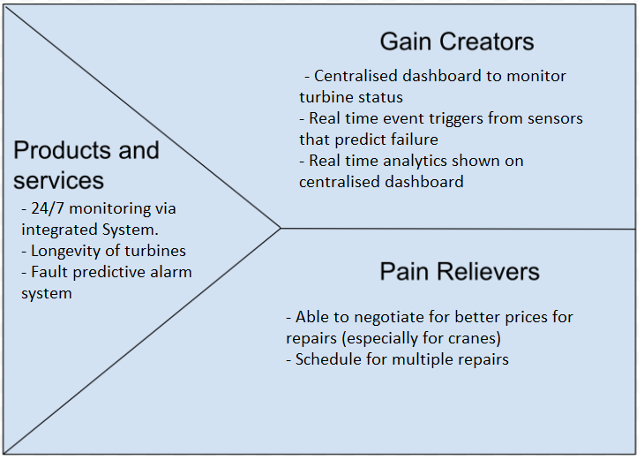

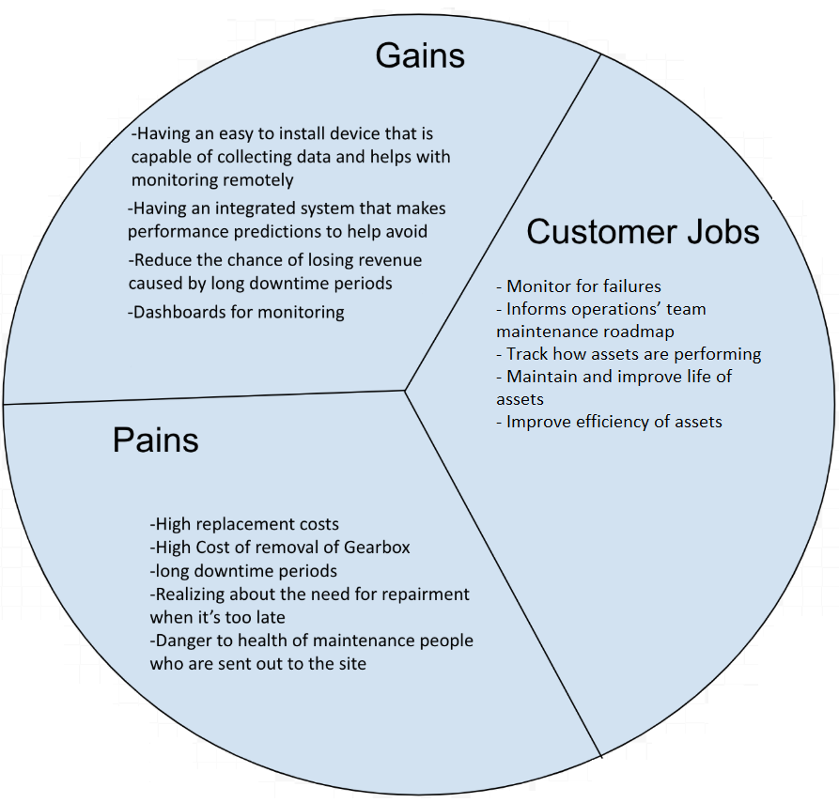

### 

### Value Network



## IoT Capability Management

### Business Capability Mode

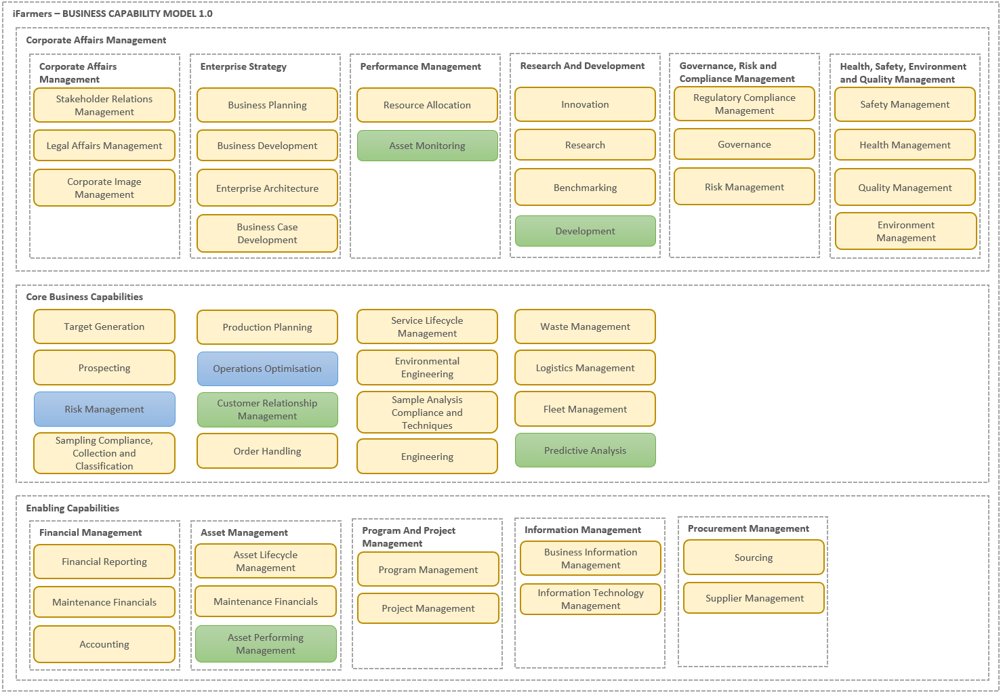

### Technology Capability Model

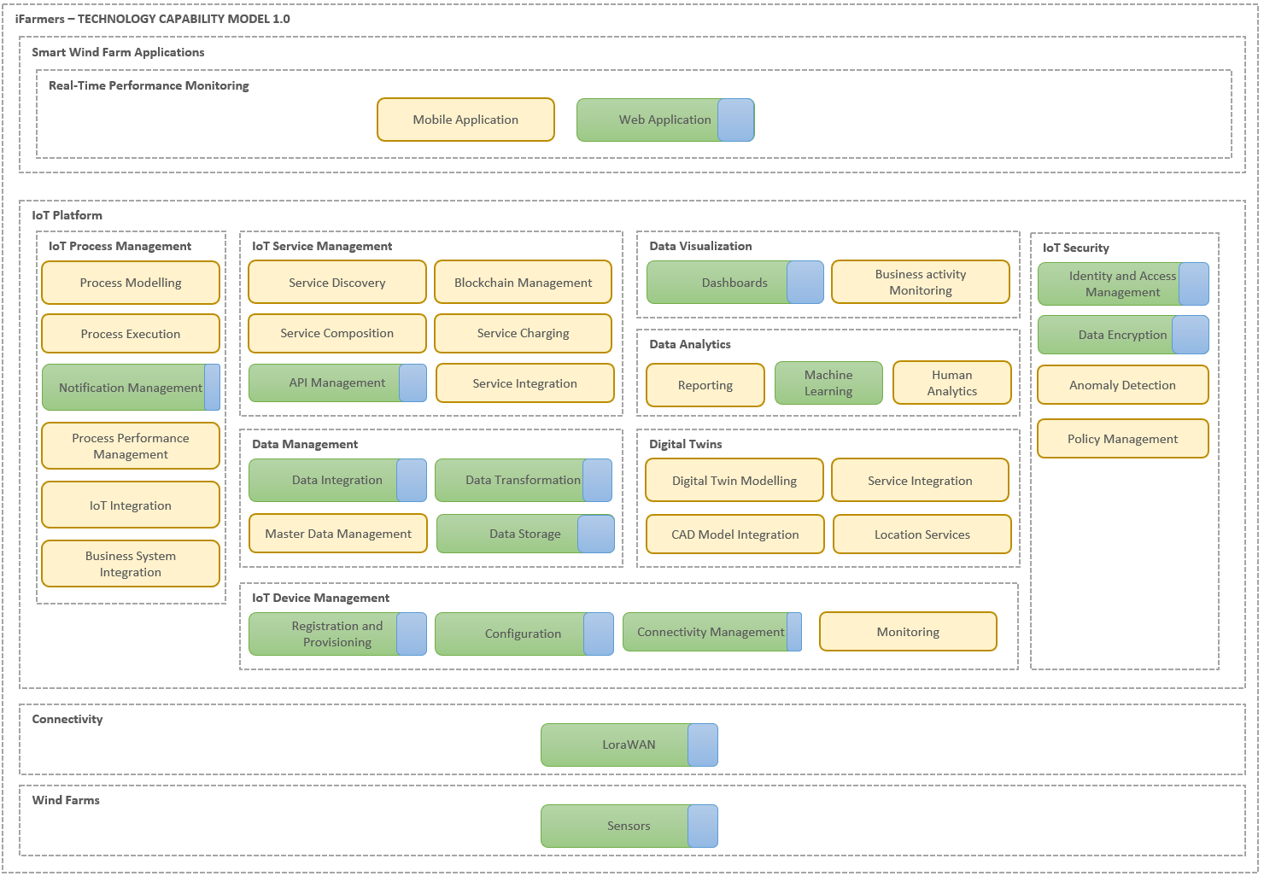

## 

## IoT Technology Strategy

|  |  |  |  |
| --- | --- | --- | --- |
| **Layer 1: Sensors.**  **Recommended choice:** Temperature sensor, accelerometer  **Reason:** Both temperature sensor and accelerometer can satisfy the criterias of the project. Both of them are also affordable. | | | |
| IoT Sensor Options | Pros | Cons | Cost |
| Temperature sensor | 1. Can be positioned around bearings and oil in the gearbox to monitor the temperature of each part of the gearbox.  2. Durability is very good. Need for replacing the sensor is low.  3. Is simple to apply the sensors to the hardware | 1. May need multiple sensors to monitor different parts of the gearbox. | Relatively Low |
| Accelerometer | 1. Vibration implies how smooth the gears and bearings run. can be used to predict failure.  2. Easy to fix the sensor on the stationary part. | 1. may need multiple sensors to monitor different parts of the gearbox.  2. Durability is not as high as the temperature sensor but is still acceptable. | Medium |
| force sensor | 1. Force sensors can be placed on the bearing to see the force change in matter of time. It can be transformed into vibration data and further analysed to predict failure.  2. Durability is good. | 1.Very hard to integrate into the axis so its applicability is very low. | Relatively Low |

|  |  |  |  |
| --- | --- | --- | --- |
| **Layer 2: Connectivity**  **Recommended choice:** LoRaWAN  **Reason:** Working with assets that are kilometers away from a control panel, we need something that has a very large range. LoRaWAN can accommodate that and also is relatively cheap. | | | |
| IoT Networks | Pros | Cons | Cost |
| RFID | 1. Supports various frequencies  2. Low energy consumption | 1. Limited distance (less than 10m) | Relatively low |
| NFC | 1. Compatible with most RFID high-frequency related standards  2. The chip can communicate with each other  3. Can be connected for a short time | 1. Limited distance (less than 10m) | Relatively low |
| WIFI | 1. Feature Simplicity  2. High Bandwidth and speed  3. Held to a higher security standard | 1. Would need additional wireless adapters to translate between data and radio signals  2. Easily obstructed by obstacles  3. Wi-Fi signal will degrade as more devices join | Relatively low |
| Bluetooth | 1. Feature Simplicity  2. Data safety | 1. High power consumption  2. The connection can sometimes run very slow | Relatively low |
| 5G | 1. Extremely high bandwidth | 1. High power consumption  2. High installation costs(Tower)  3. High maintenance cost | Relatively high |
| 3G/4G | 1. Supported by older devices  2. Stable  3. Sufficient bandwidth | 1. Reduce battery life  2. Easily obstructed by obstacles | Relatively high |
| LTE-M | 1. Sufficient bandwidth | 1. Unknown problems caused by new technologies | Relatively high |
| NB-IoT | 1. Sufficient bandwidth  2. Low power consumption  3. Signal can go through the wall | 1. Unknown problems caused by new technologies | Relatively high |
| LoRaWAN | 1. Great signal range  2. Increase gateway capacity | 1. LoRaWAN stack is only available through Semtech | Relatively low |
| Sigfox | 1. Great signal range  2. Bidirectional functionality | 1. Can't handle frequent data  2. Sending data back to the sensor / device is severely limited | Relatively low |
| Satellite | 1. Large signal range  2. No geographical restrictions | 1. High delay  2. Limited satellite number | Relatively high |

|  |  |  |  |
| --- | --- | --- | --- |
| **Layer 3: Edge Computing**  **Recommended choice:** Arduino  **Reason:** Both Arduino and Raspberry Pi can do the job. Although Raspberry Pi has better capability, Arduino is far more than efficient. This is because Arduino is robust, cheaper and lower power consumption. | | | |
| Options | Pros | Cons | Cost |
| Arduino | 1. Robustness is good  2. power consumption is low. | 1. Capability is low, not for a very complex edge computing | Relatively Low |
| Raspberry Pi | 1. Capability is very good, and can run multiple programs at the same time. | 1. Robustness is relatively low because it has to run an operating system inside.  2. The power requirement is relatively high | Relatively High |

|  |  |  |
| --- | --- | --- |
| **Layer 4: Data Accumulation**  **Recommended Choice:** Azure  **Reason:** Azure offers stability as a platform. What the attraction of using Azure is the platform consistency with other layers. | | |
| Options | Pros | Cons |
| Azure | 1. Can provide integration of devices through MQTT or HTTPS protocols  2. The windfarm project is expected to perform for several years. The stability of the platform is of vital importance. Azure is currently the largest platform, and has more enterprise-level suites and services.  3. Azure platform were considered to use in both layer 4 and 6.It would be better to maintain platform consistency | 1. The current iteration of the Microsoft Azure Management Console is frustrating to work with.  2. Custom images are unsupported and require you to maintain them as you would in your own on-site lab. |
| AWS | 1. The price of AWS is relatively low.  2. Can provide integration of devices through MQTT or HTTPS protocols  3. The windfarm project is expected to perform several years.The stability of the platform is of vital importance.Azure is currently the largest platform, and has more enterprise-level suites and services. | 1. AWS limits some of its features which cannot be changed at all (EC-2 classic, EC2-VPC) which might lead to safety issues. |

|  |  |  |
| --- | --- | --- |
| **Layer 5: Data Abstraction**  **Recommended choice:** Azure SQL  **Reason:** Effort for setup of software and integrating is manageable. We get an API gateway with security benefits of an SQL database. The attraction of using Azure because of platform consistency with other layers is also present. | | |
| Options | Pros | Cons |
| Azure SQL | 1. Better integration with Microsoft's inherent product line, and high integration with Visual Studio, get started quickly. And it should be faster to migrate existing Windows technologies to Azure.  2. Provide API Gateway Service.  3. SQL based database improves system security.  4. Azure platform were considered to use in both layer 4 and 6.It would be better to maintain platform consistency | 1.Compared with NoSQL, the relationship of sql is more complicated and the performance is relatively low. |
| Azure Redis (Nosql） | 1. Better integration with Microsoft's inherent product line, and high integration with Visual Studio, get started quickly. And it should be faster to migrate existing Windows technologies to Azure  2. Azure platform were considered to use in both layer 4 and 6.It would be better to maintain platform consistency.  3. Provide API Gateway Service  4. Because there is no coupling between data based on key-value pairs, it is very easy to scale. | 1. A SQL database  is necessary to ensure high security data access |
| AWS RDS(SQL) | 1. The price of AWS is low, but this advantage is very weak. The data processing cost of this scale accounts for a small proportion of the total expenditure. | 1. Azure platform has been chosen for other layers. It would be better to maintain platform consistency.  2. The Windfarm is a big project however  AWS provides first and foremost consideration for small businesses and it asks for enterprise level supporting service. |

|  |  |  |
| --- | --- | --- |
| **Layer 6: Data Application**  **Recommended choice: Azure IoT Central**  **Reason:** Is a simple container lifecycle manager. We can maintain platform consistency with other players and it has a fully managed SaaS solution, making it enterprise users friendly. | | |
| Options | Pros | Cons |
| Azure IoT Central | 1. Azure platform was considered to be used in both layer 4 and 5.It would be better to maintain platform consistency.  2. It uses Container Service (AKS) and uses Container Registry for [Docker container registry](https://www.educba.com/docker-vs-vms/) to simplify container lifecycle management.  3. Azure provides the facility for enterprise users so that they can use current active directory accounts to sign on the Azure cloud platform and runs .net framework on Windows, Linux, and MacOS.  4. Azure IoT Central is a fully managed SaaS solution that uses a model-based approach to help users without expertise in cloud-solution development build enterprise-grade IoT solutions. | 1. Lack of Hyper-V Snapshot Support  2. Provisioning Virtual Machines in the Cloud Takes Longer than On-Premise  3. Lack of Integrated Backup |
| AWS IoT Central | 1. provides secure, resizable compute capacity in the cloud. It is designed to make web-scale computing easier for developers.  2. AWS is excellent for open source developers as it welcomes Linux users and offers several integrations for different open source applications. | 1. Azure platform was considered to be used in both layer 4 and 5.It would be better to maintain platform consistency.  2. AWS does have general cloud computing issues such as when you move to a cloud, downtime, limited control, and backup protection can occur. |

|  |  |  |
| --- | --- | --- |
| **Layer 7: Collaboration & Processes**  **Recommended choice:** Trello, Google drive  **Reason:** Both are online platforms that offer great services regardless of the possibility of safety issues. Trellos offers a great way to ticket work while google drive makes it simple to dropbox for files and collaborative files. | | |
| Options | Pros | Cons |
| Trello | 1. Can be used as a project management tool to delegate work to people.  2. Maintains a clear look of the plan.  3. It’s free. | 1. Online platforms may have security problems.  2. Need internet connection to access. |
| Google drive | 1. Have huge space to share the documents.  2. Multiple people can work on the same file at the same time.  3. It’s free | 1. Online platforms may have security problems.  2. Need internet connection to access. |

**Final choices:**

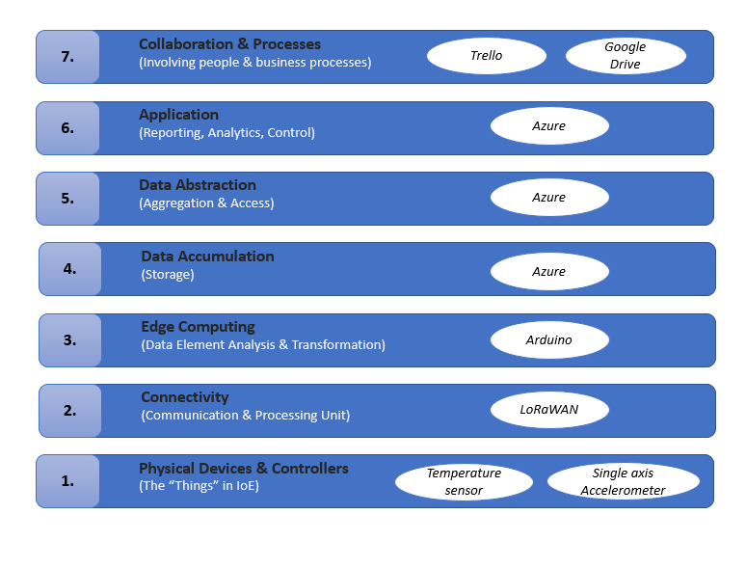

## 

## 

## 

## IoT Strategic Roadmap

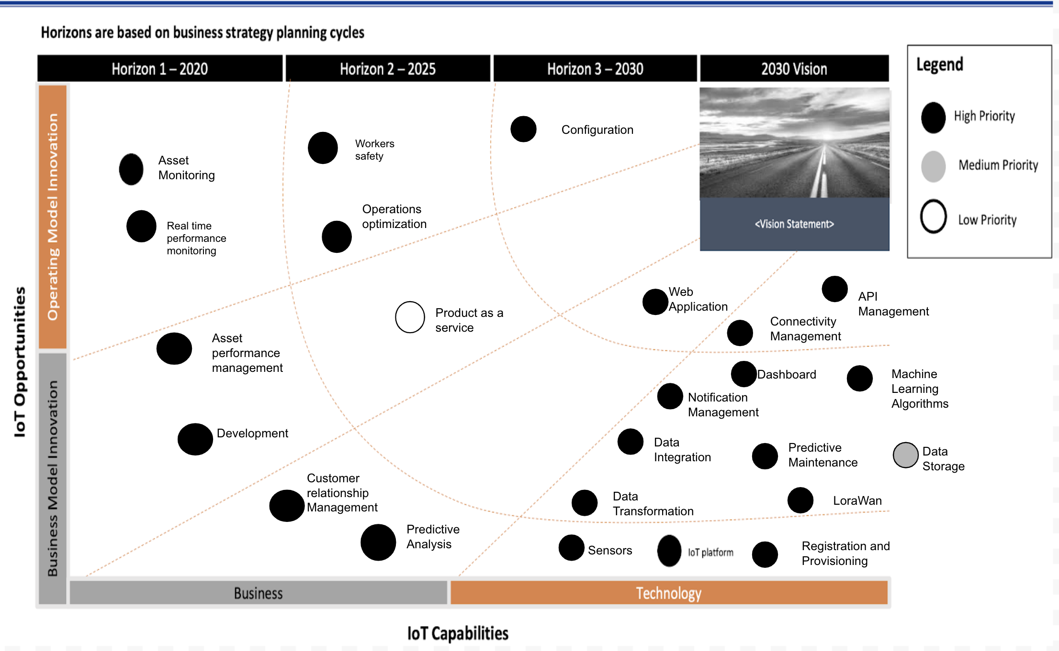

## Business Value Management

### Balanced Score Card

### 

|  |  |  |  |
| --- | --- | --- | --- |
| **Financials** | | | |
| Objectives | Measures | Targets | Initiatives |
| Increase market share | Increase in number of wind farms that use our technology | 15% revenue per year | More reliable data and better predictions. Leads to increase in client base |
| Increase market opportunities | Increase product features for wind farm | 10% revenue per year | Perform interviews with customers to find out possible enhancements in the product |
| Reduce costs | Technology implemented | 10% cost reduction | Evaluate alternative technological solutions (open source) |

|  |  |  |  |
| --- | --- | --- | --- |
| **Customer** | | | |
| Objectives | Measures | Targets | Initiatives |
| Reduce costs on maintenance of wind turbines | Less number of maintenance people have to be sent out to site for checks and replacements | 50% decrease | Monitor the wind turbine performance remotely |
| Improving Wind Turbine Reliability | Increase uptime period | 5% increase | Predict possible failures in wind turbines |
| Improve customer satisfaction | Increase customer satisfaction index | >= 80% of evaluations with a good satisfaction index. | Take into consideration feedback from the customer and improve weak points |

|  |  |  |  |
| --- | --- | --- | --- |
| **Internal Business process** | | | |
| Objectives | Measures | Targets | Initiatives |
| Improve stock reliability | Number of sensors in stock | 25% increase | Have enough sensor stock in case of failures in these |
| Improve customer service | Improve response time | Maximum 2 hours to respond | Create a help desk area, with different support levels |

|  |  |  |  |
| --- | --- | --- | --- |
| **Learning and Growth** | | | |
| Objectives | Measures | Targets | Initiatives |
| Employ Skilled people | Increase data scientists and wind farm specialist | Reach having 2 data scientists, 3 wind farm specialists in staff | Hire high skilled data scientists and wind farm specialist |
| Spread our system to different countries | Increase the number of countries demanding wanting to use our technology for remote monitoring | 20% increase | Provision reliable data to customers and user then market to advertise our technology |

|  |  |  |
| --- | --- | --- |
| **Initiatives / Capabilities Mapping** | | |
| Dimension | Initiatives | Capabilities |
| Financials | More reliable data and better predictions, therefore increase in client base | Sensors, Data Encryption, Machine Learning, Data Integration, Data Transformation, Predictive Analysis |
| Financials | Perform interviews with customers to find out possible enhancements in the product | Customer Relationship Management |
| Financials | Evaluate alternative technological solutions (open source) | Data Integration, Data storage, API Management |
| Customer | Monitor the wind turbine performance remotely | Asset Monitoring, Web Application, Dashboard, Asset Performance Management, API Management |
| Customer | Predict possible failures in wind turbines | Machine Learning, Predictive Analysis, Sensors, Notification Management |
| Customer | Take into consideration feedback from the customer and improve weak points | Customer Relationship Management |
| Internal Business Process | Have enough sensor stock in case of failures in these | Sensors, Registration and Provisioning, Configuration, Connectivity Management |
| Internal Business Process | Create a help desk area, with different support levels | Customer Relationship Management |
| Learning and Growth | Hire high skilled Data scientists and Wind farm Specialist | Development |
| Learning and Growth | Provision of reliable data to customers and user of marketing in order to advertise our technology | Sensors, Data Encryption, Machine Learning, Data Integration, Data transformation, Predictive Analysis |

# IoT Architecture

**Enterprise Architecture Framework**

Demonstration of our enterprise architecture is as shown below in the business motivation model, done in “vision and value-driven” format. This model is an updated version of the example diagram provided in the lecture. This is broken into 2 levels: business viewpoint and usage viewpoint. Usage viewpoint and system requirements will be covered in the solution architecture section.

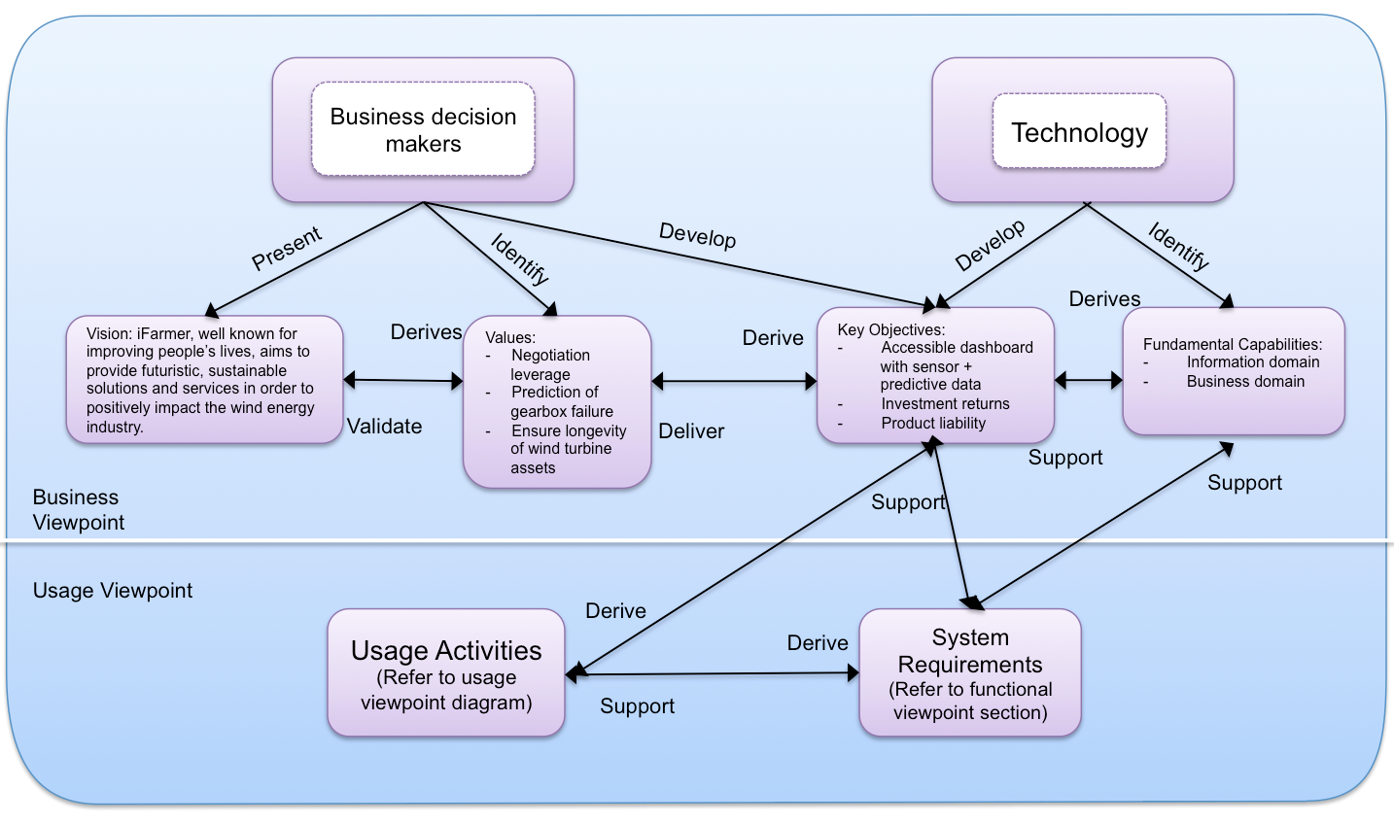

**Business Viewpoint:**

The employees are broken into 2 primary groups: business decision makers (stakeholders) and the technologies team.

The decision makers involve people who drive the development of IIoT systems within their business and push for the company’s vision, values and key objectives. This includes but is not limited to the CEO, CFO and managers. These stakeholders present the company’s visions identify values and develop key objectives to work off from. Their interests of utilising IIoT lies with corporate matters such as business value/gain, investment returns, cost of maintaining the system and product liability. If IIoT is able to align with the vision, values and key objectives of the company then together with the technologies team, both parties will work to apply such changes.

The technologies team involves system engineers, product managers and others. The technologies team have two concerns: key objectives and fundamental capabilities. Within the fundamental capabilities, this team looks to ensure that IIoT and its domains will be implemented and supported in the business’ existing frameworks.

**Vision:**

Our vision is to “aim to provide futuristic, sustainable solutions and services in order to positively impact the wind energy industry”. This vision works collaboratively with energy companies like AGL Energies that have the vision “At **AGL** we have a passionate belief in progress – technological and human – and a relentless determination to make things better for you, our communities, the Australian economy, and our planet.” AGL Energy involves themselves with different facets of energy and owns wind farms in Australia like Hallett Wind Farm. This stays consistent with our vision as well and for other energy companies that are in the wind energy industry.

**Values:**

With the growing use of offshore wind farms to generate energy for consumers, the desire to improve wind farms have increased. The implementation of IoT technologies, along the services we provide, contribute to the longevity of wind turbine assets. Our vision to provide sustainable solutions within the wind energy industry is reflected through the potential money that can be saved with IoT. Our sensors pick up heat and vibration data to make predictive data that can help monitor potential failures in wind turbine gearboxes. Being able to predict when a gearbox will completely fail allows a site manager to have negotiation leverage on hiring cranes to assist in servicing/replacing this part. Being able to have the flexibility to moderate for a lower price. This could save up to $30,000 AUD.

**Key Objectives:**

Key objectives are particular values that the business expects that the IIoT will provide. Within the wind farm industry, this may include:

* Having an accessible dashboard with real time data in regards to the logistics of the gearbox
  + Triggers to inform monitors that something is wrong
* Investment return
  + Money saved from crane hire
  + Money saved from preventing from breaking gearbox
  + Longevity of wind turbine
* Cost of maintenance
  + Sensors are sturdy and have long battery life so there is a little need for maintenance
* Product liability
  + Quality Assurance
  + Quality control

F**undamental Capabilities:**

Expressing the fundamental capabilities requires understanding of how key objectives will be implemented. From the vision of the company, we delineated how IIoT can bring value to our customers in the wind farm industry through the means of sensors and predictive analysis. We will explore different domains in order to implement these capabilities alongside the key objectives. Referring to our implementation viewpoint diagram, the following domains will manage the key objectives above:

Information domain: This domain will handle the storage of data on the cloud, data transformation + integration and predictive analysis with machine learning. (add detail to do with key objectives) This is how the customers will receive reliable information of potential faults in wind turbine gearboxes and the means of how they will eventually make back their investment. To calculate how much money will be saved, a periodic financial rundown will be required in relevant sectors such as hiring of external repair teams and on site crew, replacement parts etc. Additionally, the utilisation of services such as Azure ensures security of data.

Application domain: This domain will handle the UI that the customers will see. On this dashboard we will provide real time sensor data as well as predictive logistics for potential faults in wind turbine gearboxes. This ensures that the customer has access to a dashboard that displays real time logistics.

Product liability is ensured by quality assurance and control. Constantly updating the machine learning algorithm with every successful/failed trigger will improve the quality of the system over time. Before putting our services and systems on the market, we can quality test our analytics to ensure that we provide a high enough positive to false readings ratio.

**Solution Architecture**

**Usage Viewpoint**

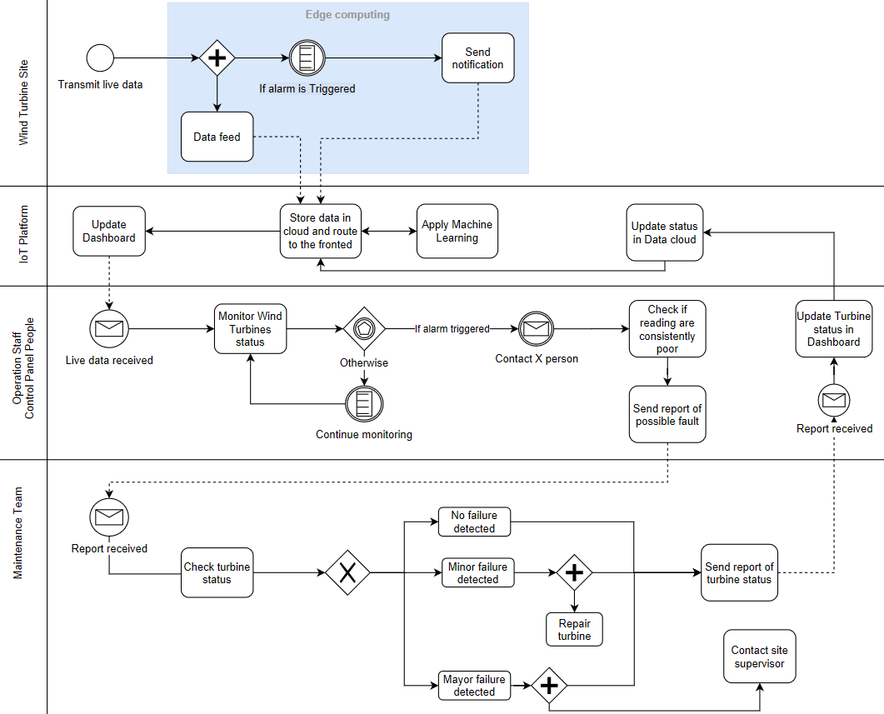

|  |  |
| --- | --- |
| Symbol | Description |
|  | Sequence flow |
|  | Message flow |
|  | General start |
|  | Process / task |
|  | Parallel gateway |
|  | Conditional boundary interrupting |
|  | Message standard |
|  | Message boundary interrupting |
|  | Multiple gateway boundary interrupting |
|  | Exclusive gateway |

**Functional Viewpoint**

A functional domain is a way of dividing a typical IIoT system into smaller domains that highlight the important elements that have wide applicability in many industrial verticals. An IIoT system consists of the following functional domains:

* Control domain
* Operations domain
* Information domain
* Application domain
* Business domain

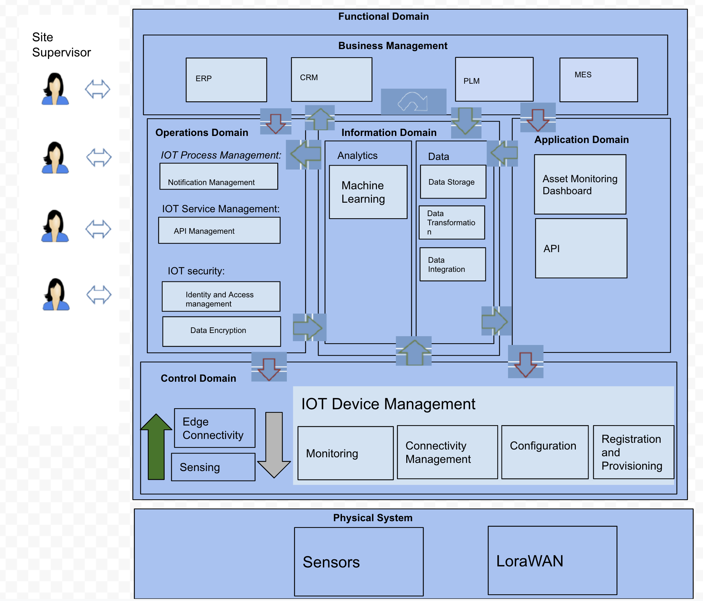

In the diagram above:

* Green arrows show how data collected by sensors is processed across domains
* Red arrows shows control flows, order of software operations, across domains

**Control Domain:**

The control domain consists of functions which have the responsibility of consuming data from sensors , and performing machine learning operations on the data. In our system the control domain only consists of sensors for sensing and collecting data and edge connectivity for filtering and cleaning up our data.

*fig. Control Domain decomposition* 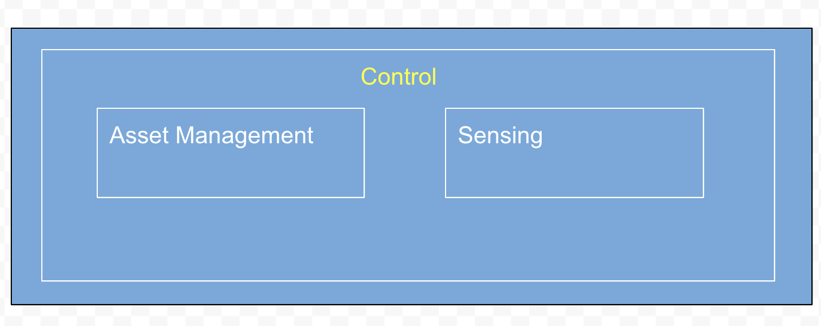

*Control Domain decomposition*

Sensing: functions that consume data from sensors in our system. These functions will be in charge of reading data such as temperature and vibration from the sensors installed in the wind turbine gearbox.

Asset management is for operations management associated with the whole system and mainly the control systems. Some examples would be provisioning and registration of sensors and/or fault management and identification management when communication fails.

**Operations Domain:**

The operations domain includes functions responsible for the onboarding and recruitment of sensors, management operations and improvement of asset reliability and performance inside the systems.

*fig .Operation Domain decomposition* 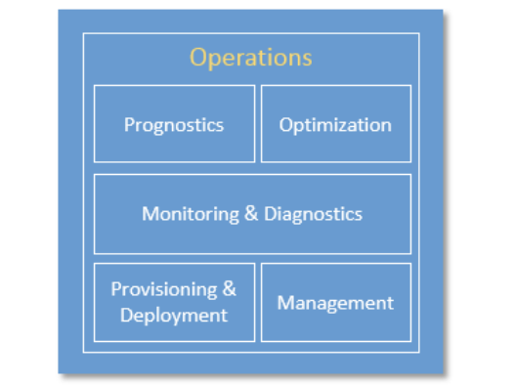

Provisioning and Deployment: holds functionality that can be used to configure, register and track our sensors remotely in a secure manner.

Management: set of functions that allows the assets management centers to communicate with the control systems using specific commands.

Monitoring and Diagnostics are functions that allow for:

1, Prediction of the possibility of problems or failures in wind turbines

2. Real-time monitoring of asset fault indicators, the temperature and vibration of gearbox

3. Collection of data to supplement predictive analysis model

4. Alerting on when things change from their normal state For example, detection of abnormal patterns looking at the sequence of data obtained over time producing alerts on when the temperature of a gearbox exceeds the threshold

Prognostics consists of the set of functions that serves as a predictive analytics engine of the IIoT systems. It relies on historical data of asset operation and performance to identify potential issues before they occur and provide recommendations on their mitigation. This could be predictions on when failures occur or when maintenance is needed.

Optimisation consists of a set of functions that improves asset reliability and performance and increases availability and output in correspondence to how the assets are used. With the ability to capture and identify major events, such as downtime, delay it is easier to analyze and assign causes for known problems.

**Information Domain:**

The information domain represents the functions used for gathering data from other domains, moreso the control domain. It then transforms the data to give us a better understanding about the overall system.

*fig. Business, application and information domains*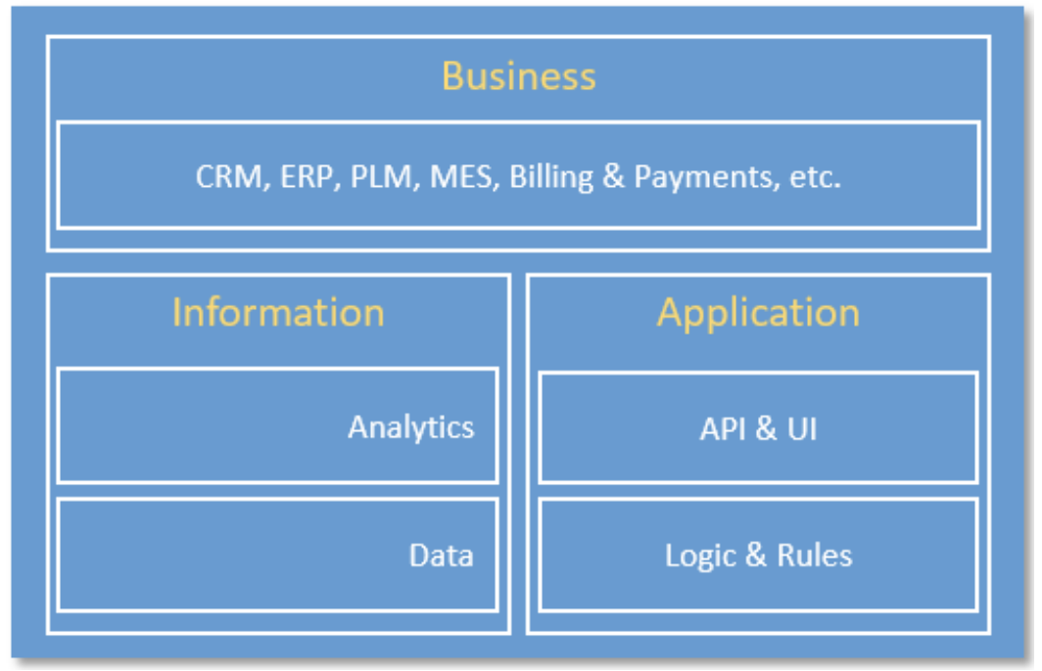

Functions in data include:

* Collecting sensor and operation state data from all domains
* Data filtering through the use of edge connectivity

A set of functions for data analytics and using machine learning provides predictions based on data gained. We can also analyse the data coming from sensors in context of what’s happening in the outside world. For example we can take into account factors such as weather, downtime due to maintenance to give better predictions and analysis.

**Application domain:**

The application domain holds functions that implement application logic that assists with the display of predictive and real time sensor data.. These functionalities can be aimed at different users and different groups of people and can be targeting specific groups like a site manager, technicians and the operational managing team.

APIs are interfaces that provide programs and/or libraries of functions that offer functionality when building software applications. This is especially helpful to use due to how infrastructure has been already built. Connecting sensors to a gateway and uploading data on the cloud becomes fast tracked due to open sourced resources.

UI enables human interactions with the application. For example in our system the dashboard UI will allow humans to remotely gain information about the current status and performance of wind turbines.

**Business domain:**

The business domain functions will allow for easier completion of operations associated with internet of things systems.They do this by integrating IOT systems with industrial internet systems in order to achieve specific business goals such as improving their client satisfactions . To do this, we provide an ERP interface. This allows smoother integration of our solutions to the customer’s business system.

**Implementation Viewpoint**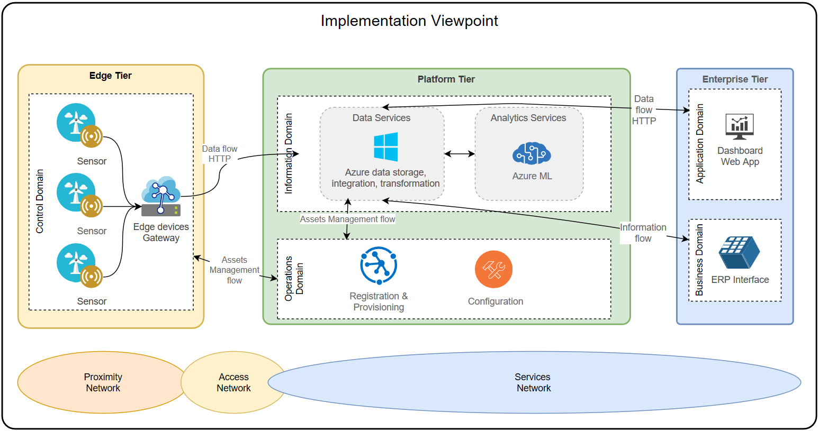

**Control domain:**

It is composed of edge components such as temperature sensors, edge computing devices and gateway. The sensors are located in each wind turbine and are in charge of sending the data captured to the Edge device/gateway. Finally, the data is transmitted from the gateway to Azure platform by HTTP protocol.

**Information domain:**

It is composed by two main components;

* Azure Data Services: software platform that provides cloud services about storage, integration and transformation of data to keep persistence of the sensors data
* Azure Analytics Services: software platform that provides cloud services for doing predictive analysis by applying machine learning algorithms to the gathered data from the sensors

**Operations domain**:

It consists of services that provide registration & provisioning functions for the edge components described in the control domain and the respective configuration of them. This is used to enable or disable an edge component in the solution.

**Application domain:**

It refers mainly to the Dashboard web application. A supervisor/manager can monitor the status of each turbine in terms of sensor data obtained from Azure platform. The dashboard will send an alert if there is a possible failure in one or more turbines. In addition, when an alert is raised, a supervisor/manager will be able to provide feedback to the system through the dashboard by indicating if effectively the failure occurred.

**Business domain**:

It consists of systems such as an ERP to which the IoT solution can potentially connect, for example, to automatically generate an inspection order in case an alarm is raised on the dashboard.

**Connectivity**

In order to develop a set criteria for the connectivity options, we need to outline the context of our challenge. Farms can have up to 150 turbines that are spaced out by at least 7 rotor blade lengths (approx. 700 meters) and the control rooms can be kilometers away. With a lot of turbines needing to be potentially monitored, we need to opt for a technology that is easily implemented, safe and is reliable. With the consideration of the nature of how far wind turbines are spaced out in a wind farm, we have opted for these criterias below:

1. Inbuilt security measures

2. Great signal range

3. The technology should be well developed/mature

4. Stable network

5. User friendly, implementation, utility (easy to set up, low maintenance cost)

6. Low financial cost

7. Low energy consumption (not as important as power source is within turbine)

|  |  |  |  |  |  |  |  |  |  |  |  |  |  |  |  |  |  |  |  |  |  |  |  |  |  |  |  |  |  |  |  |  |  |  |  |  |  |  |  |  |  |  |  |  |  |  |  |  |  |  |  |  |  |  |  |  |  |  |  |  |  |  |  |  |  |  |  |  |  |  |  |  |  |  |  |  |  |  |  |  |  |  |  |  |  |  |  |  |  |  |  |  |  |  |  |  |  |
| --- | --- | --- | --- | --- | --- | --- | --- | --- | --- | --- | --- | --- | --- | --- | --- | --- | --- | --- | --- | --- | --- | --- | --- | --- | --- | --- | --- | --- | --- | --- | --- | --- | --- | --- | --- | --- | --- | --- | --- | --- | --- | --- | --- | --- | --- | --- | --- | --- | --- | --- | --- | --- | --- | --- | --- | --- | --- | --- | --- | --- | --- | --- | --- | --- | --- | --- | --- | --- | --- | --- | --- | --- | --- | --- | --- | --- | --- | --- | --- | --- | --- | --- | --- | --- | --- | --- | --- | --- | --- | --- | --- | --- | --- | --- | --- | --- | --- |
| **Connectivity Choice:** LoRaWAN   |  |  |  |  |  |  |  |  | | --- | --- | --- | --- | --- | --- | --- | --- | | **Features /**  *Connectivity* | **Security Encryption** | **Signal Range** | **Established** | **Stability** | **Ease of Implementation** | **Cost** | **Energy Consumption** | | *RFID* | Weak | Low | Well | Stable | Easy | Low | Relatively Low | | *NFC* | Strong | Low | Well | Stable | Easy | Low | Relatively Low | | *WiFi* | Strong | Low | Well | Not Stable | Hard. Needs additional wireless adapters | Low | High | | *Bluetooth* | Weak | Low | Well | Not Stable | Easy | Low | High | | *5G* | Strong | High | Not Well | Stable | Easy | High | High | | *3G/4G* | Strong | High | Well | Not Stable | Easy | High | High | | *LTE-M* | Strong | High | Not Well | Stable | Easy | High | High | | *NB-IoT* | Strong | High | Not Well | Stable | Easy | Low | Relatively Low | | *LoRaWAN* | Strong | High | Well | Stable | Easy | Low | Low | | *Sigfox* | Strong | High | Well | Not Stable | Hard | High | High | | *Stellite* | Strong | High but high delay | Well | Not Stable | Hard | High | High | | |
| Connectivity | Evaluation |
| RFID | 1. Has weak encryption  2. Low signal range. Cannot cover the whole wind farm  3. Well developed  4. Network is stable  5. It is easy to implement  6. Low cost  7. The energy consumption is relatively low |
| NFC | 1. Has strong encryption  2. Low signal range. Cannot cover the whole wind farm  3. Well developed  4. Network is stable  5. It is easy to implement  6. Low cost  7. The energy consumption is relatively low |
| WIFI | 1. Has strong encryption  2. Low signal range. Cannot cover the whole wind farm  3. Well developed  4. WIFI signal is not stable. Signal will be easily obstructed by obstacles and the signal will degrade as more devices join  5. Hard to implement. WIFI needs additional wireless adapters to translate between data and radio signals  6. low cost  7. The energy consumption is high |
| Bluetooth | 1. Has weak encryption  2. Signal range can not cover the whole wind farm  3. Well developed  4. Network is not stable,the connection can sometimes run very slow  5. It is easy to implement  6. low cost  7. Relatively high power consumption |
| 5G | 1. Has strong encryption  2. Signal range can cover the whole wind farm  3. Not well developed  4. Network is stable  5. It is easy to implement  6. Because 5G is a new technology it will include high installation osts and high maintenance cost  7. High power consumption. |
| 3G/4G | 1. Has strong encryption  2. Signal range can cover the whole wind farm  3. Well developed  4. Network is not stable,it easily obstructed by obstacles  5. It is easy to implement,but this technology will reduce battery life  6. High cost  7. Relatively high power consumption. |
| LTE-M | 1. Has strong encryption  2. Signal range can cover the whole wind farm  3. Unknown problems caused by new technologies  4. Network is stable  5. It is easy to implement  6. High cost  7. Relatively high power consumption. |
| NB-IoT | 1. Has strong encryption  2. Signal range can cover the whole wind farm  3. Unknown problems caused by new technologies  4. Network is stable  5. It is easy to implement  6. High cost  7.Relatively high power consumption. |
| LoRaWAN | 1. Has strong encryption  2. Signal range can cover the whole wind farm  3. Well developed technology  4. Network is stable  5. It is easy to implement  6. low cost  7. Relatively low power consumption. |
| Sigfox | 1. Has strong encryption  2. Signal range can cover the whole wind farm  3. Well developed technology  4. Network is stable,but sending data back to the sensor / device is severely limited  5. It is easy to implement  6. low cost  7. Relatively low power consumption. |
| Satellite | 1. Has strong encryption  2. Signal range can cover the whole wind farm,but there are high delay in data transition  3. Well developed technologyHigh power consumption.  4. Network is not stable  5. It is hard to implement  6. high cost  7. High power consumption. |

**Reason of choice:**

Working with assets that are kilometers away from a control panel, we need a technology able to cover a large range of connectivity. LoRaWAN signal range can cover practically a whole wind farm and also it is a relatively cheap option. Another important aspect of LoRaWAN is that it is secure in terms of data transmission and it is a well developed technology. The power consumption in this case is not relevant, due to wind turbines can provide energy to the devices.

**Security**

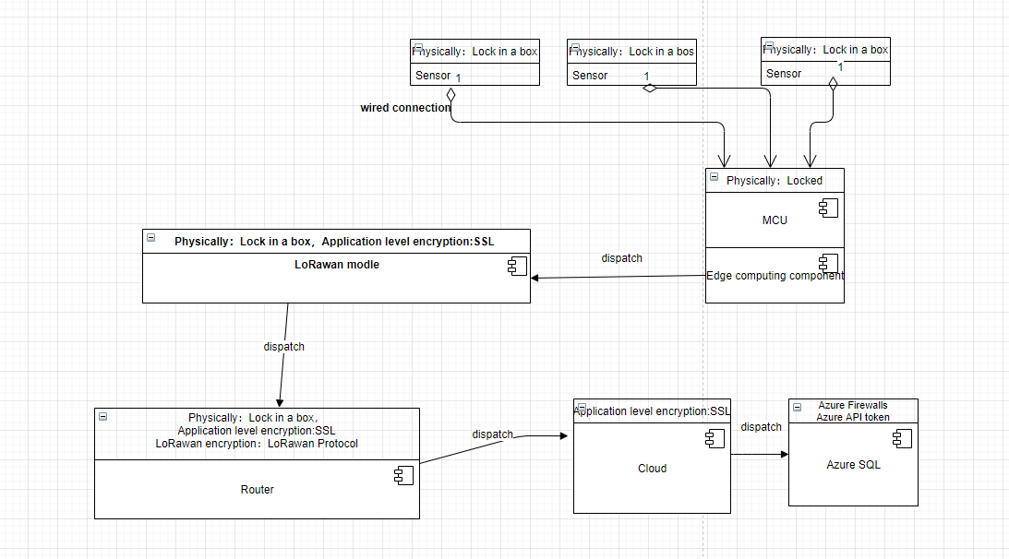

*fig. Dataflow UML diagram*

**IoT endpoint/device protection:**

Sensors are located in the gearbox and the LoRaWAN modules are wired to the controller board. The controller board can be locked in a metal box to prevent general physical access and can be placed near the gearbox in the head of the wind turbine. The company of the windmill should have another lock in the head such that only authorised staff can get access to the gearbox and the controller board box.

**Data-in-motion protection:**

Data from LoRaWAN module in the gearbox to Azure platform: SSL protocol though the network.

LoRaWAN has its own security protocol to protect the transmission between the Lorawan module and Lorawan gateway. The Lorawan gateway will be located at a locked room for each windmill to make sure no one but the staff can get access to the gateway hardware.

**Data-in-rest protection:**

With the Azure SQL database, we can secure data by applying a layered in-depth defence approach that includes 6 layers:

1. **Network security:** Azure SQL Database provides a relational database service for cloud and enterprise applications. To help protect customer data, firewalls prevent network access to the database server until access is explicitly granted based on IP address or by Azure Virtual network traffic origin.

2. **Access management:** SQL database access management enables a user when connecting to [Azure SQL Database](https://docs.microsoft.com/en-us/azure/sql-database/sql-database-technical-overview) using username and password and an Azure token.

3. **Row-Level Security:** Row-Level Security enables customers to have control access on rows in a database table based on the characteristics of the user executing a query. This may include having group membership or the context of execution. Row-Level Security can also be used to implement custom label-based security concepts.

4. **Threat protection:** SQL Database secures customer data by providing auditing and threat detection capabilities.

5. **Information protection and encryption:** In Azure, all newly created SQL databases are encrypted by default and the database encryption key is protected by a built-in server certificate. Certificate maintenance and rotation are managed by the service and require no input from the user. Customers who prefer to take control of the encryption keys can manage the keys in [Azure Key Vault](https://docs.microsoft.com/en-us/azure/key-vault/key-vault-secure-your-key-vault).

6. **Security management**: Use vulnerability assessment to configure services that can discover, track, and help remediate potential database vulnerabilities with the goal to proactively improve overall database security.

# 

# IoT Solution Design

IoT Solution Design

**Requirements**

*What is the business problem you are solving with IoT? List the software and hardware requirements that a solution would need to fulfil. Put together a requirements document. You can also start a test planning document based on your requirements – what you test.*

|  |  |  |  |  |  |
| --- | --- | --- | --- | --- | --- |
| Software Requirements | | | | | |
| Req. ID | Module | Req. Name | Description | Acceptance Criteria | Category |
| FR1 | Dashboard | Main panel | Users must be able to view the status of each turbine installed in their farms after logging in on the home dashboard. | Each turbine's status that belongs to the current wind farm have to be represented as follows:   * A circle with a status color:   + *Green*: Working properly   + *Orange*: Possible Failure   + *Red*: Failure occurred * Current Temperature * Internal ID | Functional Requirement |
| FR2 | Dashboard | Main panel | User can swap to another wind farm panel by selecting it from a combobox. | The system should offer the flexibility of changing settings such as changing the wind turbine that is being monitored. | Functional Requirement |
| FR3 | Dashboard | Turbine Logistics | Users will see more detailed logistics of a turbine by tapping the corresponding coloured circle | After a user taps on the status circle of a turbine, they will see the following information about the turbine:   * History of failures * Graph of weekly/monthly temperature readings * List of previous reports with corresponding status changes * Location of turbine   Additionally there is a “change status” button (changes status to green or red). | Functional Requirement |
| FR4 | Dashboard | Possible failure in turbine | Users will be sent a notification on their dashboard when the system predicts a potential failure of a gearbox in a turbine. Additionally, that turbine’s status colour will appear orange, indicating the particular turbine requires diagnosis. | When changes to the status of the turbines are detected by the sensors:   * The status of the asset changes from "Green" to "Orange" and: * An alarm has to be displayed in the Dashboard with the incidence date/hour. It will have an intermittent message/icon for the corresponding turbine with possible failure.   To diagnose the problem, tapping on the orange circle will prompt for a report to be made and two options. These options include:   1. Setting orange colour to red, indicating failure 2. Setting orange colour to green, indicating no failure | Functional Requirement |
| FR5 | Dashboard | No failure in turbine | Users must be able to update the status (colour) of the wind turbine on the dashboard. If the technician finds no failures after visiting the site, he/she can request to change status to green. Control panel workers will then reset that turbine status to green. | Once a technician investigates the potential fault and he states that there are no failures after an on site inspection, the dashboard user taps on the orange status circle and is prompted to select options of green or red. Green will be selected to indicate no failure. The dashboard will save that information in the Azure platform and the colour of the status will be updated to green on the dashboard. | Functional Requirement |
| FR6 | Dashboard | Failure in turbine | Users must be able to update the status (colour) of the wind turbine on the dashboard. If the technician finds failures after visiting the site, he/she can request to change status to red. Control panel workers will then reset that turbine status to red. | Once a technician investigates the potential fault and he states that there are no failures after an on site inspection, the dashboard user taps on the orange status circle and is prompted to select options of green or red. Red will be selected to indicate failure. The dashboard will save that information in the Azure platform and the colour of the status will be updated to red on the dashboard. | Functional Requirement |
| FR7 | Dashboard | Resolved failure in  turbine | Users must be able to update the status of a wind turbine once the failure has been resolved, i.e. change the status colour from red to green on the dashboard. | Dashboard user can update the status of a wind turbine by tapping on the red circle  that will prompt for another report. Once the report is resolved, user can  change the colour back to green. |  |
| FR8 | Dashboard | Register/Login | Users must be able to register and log into the website app in order to access their dashboard. SSO (single sign on) can be used to integrate business logins accounts with this website. | The users should be able to login with their business login account. Users should be able to login using whatever device they want to use.  Authorisation can be handled by the IT team who have control over who has the correct rights to edit and look at the details of the wind turbine assets. | Security Requirement |
| FR9 | Dashboard | Data updates | All the data visualized in the dashboard will be updated to ensure appropriately up to date information is displayed. | Information that will be updated on the dashboard will have their own timers:   * Current temperature of gearbox (every minute) * Status change (real time) * Alert notification (real time) * History of status changes (when database is updated) | Performance Requirement |
| FR10 | Dashboard | System Monitoring | Users will receive a notification if there are software or hardware issues related to any particular module of the solution provided below | A notification will appear on the dashboard to indicate if some of devices are failing indicating a defective device. The dashboard will also be notified of connectional issues including:   * Connection to cloud * Connection to database * Connection to sensors | Functional Requirement |
| FR11 | Azure platform | Data aggregation | Data about weather temperature have to be stored | Weather data will be collected from official weather websites and stored on the AzureSQL database. | Functional Requirement |
| FR12 | Azure platform | Data analysis | Predictive analysis will be performed while considering temperature data from sensors and weather temperature. | Data taken from both the heat sensors and weather temperature will be fed to the machine learning algorithm to create a model. A notification if a failure is detected. | Functional Requirement |
| FR13 | Device Management | Provisioning, Registration and configuration | The solution have to provide a way to enable or disable devices for the edge tier | (sensors, gateway, Edge computing devices) | Functional Requirement |
| FR14 |  |  |  |  |  |

|  |  |  |  |
| --- | --- | --- | --- |
| **Hardware Requirements** | | | |
| **Req. ID** | **Module** | **Req. Name** | **Description** |
| HR1 | Transceiver for Arduino | Signal | The sensor has to have a wide signal range in order to cover at least the distance between each wind turbine (about 600 mts minimum distance). LoRaWan technology is the suggested option. |
| HR2 | Sensors, Arduino, Transceiver, Gateway | Quality | Durability has to be very good, to reduce at maximum the need for replacing it. |
| HR3 | Temperature Sensor | Network topology | Capacity to build a mesh network |
| HR4 | Edge computing/Gateway | Security | Have to provide strong encryption algorithms for data transmission to the Cloud through the Gateway |
| HR5 | Temperature Sensor | Accuracy | ±0.5 degrees |
| HR6 | Edge computing/Gateway | Processing power | Ability to preprocess data before sending to cloud |
| HR7 | Gateway | Wireless protocol | Have to support LoRaWAN and 5G technologies |

**Design**

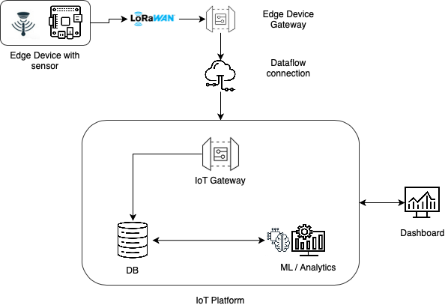

fig. high level solution design

The above diagram shows the high level design of our solution.

Edge devices installed within the turbine collect temperature and vibration data through sensors periodically. This data is then processed within the device in order to reduce the transmission payload. The processing may include cleaning, removing redundancy, compressing data etc. The processed data is then transmitted to Cloud - IoT Platform via Edge Device Gateway through secure HTTP connection.

Within the platform, once the data is received through the gateway, the data is stored in a database. The collected data is processed through the Machine Learning / Analytics engine to generate insights of the system which is presented via Web based dashboard.

**Bill of Materials**

|  |  |  |  |  |  |  |  |
| --- | --- | --- | --- | --- | --- | --- | --- |
| **Item #** | **Name** | **Ref Desc** | **Manufacturer** | **Mfr. Part#** | **Desc** | **Qty** | **Price** |
| **Hardware** | | | | | | | |
| 1 | Temperature Sensor | <https://store.arduino.cc/usa/grove-temperature-sensor> | GROVE | 101020015 | TEMPERATURE SENSOR | 1 | USD$3.50 |
| 2 | MCU motherboard with LoRaWAN module | <https://store.arduino.cc/usa/mkr-wan-1310> | Arduino | MKRWAN1310WANT | MKR WAN 1310 | 2 | USD$38.00 |
| 3 | Vibration sensor | <https://store.arduino.cc/usa/grove-6-axis-accelerometer-gyroscope>  OR  <https://store.arduino.cc/usa/grove-sound-sensor> | GROVE | 105020012  OR  101020023 | 6-AXIS ACCELEROMETER & GYROSCOPE  OR  SOUND SENSOR | 1 | USD$11.90  OR  USD$5.90 |
| 4 | Ethernet Shield | <https://store.arduino.cc/usa/mkr-eth-shield> | Arduino | 7630049200319 | MKR ETH SHIELD | 1 | USD$26.40 |
| 5 | Gateway LoRaWAN/4G | <https://www.iot-store.com.au/products/industrial-f8926-l-series-iot-lora-4g-router> | Industrial IoT | F8926GW | 3G/4G + LoRaWAN Dual Wireless Link | 1 | 449 AUD |
| **Software** | | | | | | | |
|  | Azure services | Azure SQL  Cortana  Azure IOT Hub | Microsoft |  |  | 1 | 200AUD/Month |

**Platform Design and Vendor** 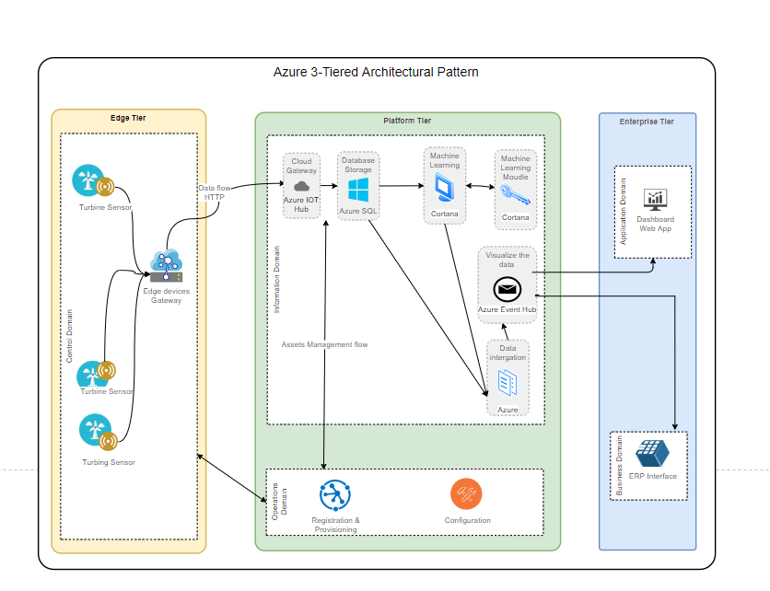

In terms of software design, the IoT platform will have to provide the following features:

* Cloud platform
* Data storage
* Data integration capabilities
* Machine Learning module
* Analytics module
* Device registration and provisioning module
* Device configuration tools

IoT Azure platform fully meets these requirements:

* Azure IOT Hub: Communicate between edge devices and Azure platform
* Azure SQL: Store temperature and vibration data.
* Cortana: Train machine learning model and apply machine learning.
* Azure Event Hub: Visualize the data ,send data to users.
* Azure IoT Hub Device Provisioning Service: Device registration and Provisioning

**Edge Design and Vendor**

|  |  |
| --- | --- |
| Hardware Device | Features and Specifications |
| Sensors | Being able to measure temperature between 0℃ to 150℃ with a deviation of +-0.5℃. |
| Being able to detect micro-vibration |
| Withstand temperature up to 500℃. |
| MCU | Being able to receive data from the sensor |
| Being able to do data pre-processing |
| Being able to make strong data encryption |
| Withstand temperature up to 500℃. |
| LoRaWan | Considering the scale of the wind farm. LoRaWan module should cover area of ​​ten kilometers in diameter |
| Withstand temperature up to 500℃ |

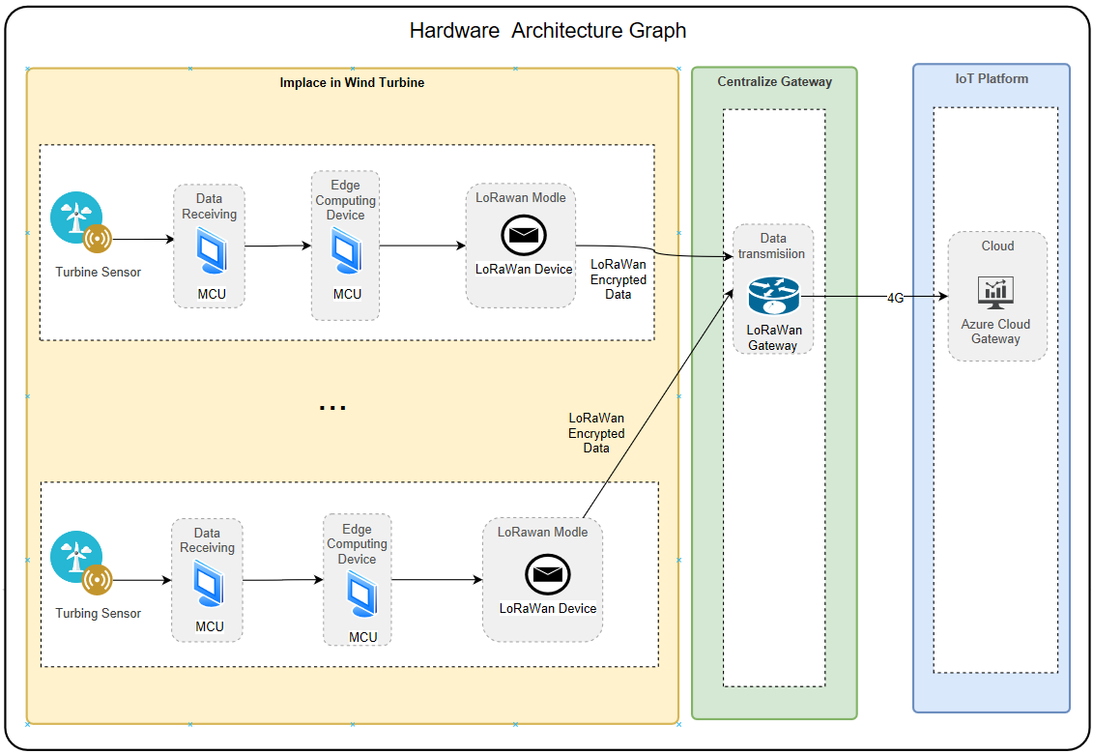

The temperature sensor will be plugged in the MCU unit. This MCU unit will transmit the temperature data to the Edge computing device (MCU/Arduino) via wire. Due to the requirements of transmission distance, we decided to use the LoRaWan module that is plugged in to the Arduino motherboard, which will send data packets to the LoRaWan gateway module with LoRaWAN technology. The gateway is connected to the internet via 4G to send the packages to the Cloud.

Each turbine will have the following components:

* Sensor and MCU to connect with the Arduino unit
* Arduino unit：it is relatively cheap in both cost and energy consumption while capable of receiving data, pre-processing and encryption of the data package
* LoRaWan Module: to communicate between the MCU/Arduino and LoRaWan gateway

There will be one centralized gateway:

* LoRaWan gateway: It receives the data from each Arduino unit via LoRaWAN technology, and it sends data to the Cloud for further data processing, via 5G.

**Testing and Integration**

|  |  |  |  |  |
| --- | --- | --- | --- | --- |
| **Test Case** | **Description** | **Preconditions** | **Steps to Reproduce** | **Expected Result** |
| **Dashboard** | | | | |
| TC1 | Users should be able to register/signup to access the dashboard | The website needs to have a form for registrations that is also linked to the backend’s database of users. | 1. Fill out the registration form using details such as: name, email address, username, password  2. There has to be a check that ensures email address entered is a correct email address format  3. Click on register | The user should be registered and they should be able to use the username and password they created to login next time |
| TC2 | Users should be able to login to the website dashboard | The user logging into the system is registered in the system | 1. Proceed to the website  2. Fill out your username and password on the login page  3. Press login | The user should be take to their dashboard home page |
| TC3 | Each user based on their rights and authorization, should view the dashboard differently | All users are assigned a level of authority | 1. The manager user, eg. site supervisor, should be able to limit the access of other roles such as a technician to certain data  2. Technician is required an authorization code to access parts of the system that has been hidden from him | 1. The permissions should enforced accordingly  2. The system should ask for an authorization code and when the code is provided the user should be able to execute the authorised |
| TC4 | User choose the wind farm they are monitoring first time they login | User needs to be logged into system and have the rights to edit on dashboard | 1. After logging in to the system, you have a search bar to try to add the name and details associated with your wind farm | The name of the wind farm is found then added. The data from your windfarm should start showing up on the dashboard. |
| TC5 | A farm’s turbines are represented as coloured circles. | A connection needs to be built to the backend database to know what the current status of the turbines are | Have a look at three different turbines with following status:  1. Working properly  2. Possible Failure  3. Failure Occured | These groups of turbines should be shown with the following circle colours:  1. Green  2. Orange  3. Red |
| TC6 | The current temperature and id of each turbine should be displayed on the dashboard next to the corresponding coloured circles. | The sensors need to appropriately provide data about wind turbines to our web application | 1. Check and make sure for all wind turbines temperature is available  2. Go on site an cross check and make sure these temperatures are accurate | Temperatures should be shown next to their turbine’s circle |
| TC7 | After clicking on a particular turbine’s circle, you will be able to see the history of failures of that turbine | A connection needs to be built to the backend database to know what the previous failure status changes were | Check for history of failures | After clicking on the turbine’s circle, you will see its history of failures alongside other logistics |
| TC8 | After clicking on a particular turbine’s circle, you will be able to see a graph of the weekly/monthly temperature sensor readings for each turbine | A connection needs to be built to the backend database to know what the failure status changes were | Check for graph of weekly/monthly temperature readings for each turbine | After clicking on the turbine’s circle, you will see its weekly/monthly temperature sensor readings alongside other logistics |
| TC9 | After clicking on a particular turbine’s circle, you will be able to see a list of the previous reports and status changes of that turbine | The sensors need to appropriately provide data about wind turbines to our web application | Check for List of previous reports with corresponding status changes | After clicking on the turbine’s circle, you will see its previous reports and status changes alongside other logistics |
| TC10 | When the predictive analysis anticipates a fault in the turbines, a notification will appear on the dashboard with the ID of the turbine and time of prediction then change the colour of that turbine's circle to orange. | The sensors need to appropriately provide data about wind turbines to our web application | 1. Simulate a change to the status of the turbine(eg change in temperature of the gearbox)  2. Check what will happen on the dashboard | 1. The colour status of the turbine’s circle should change from green to orange  2. An alarm has to be displayed in the dashboard with the incidence date/hour. |
| TC11 | To diagnose the problem in the turbines, users must be able to tap on the orange circle. They will have an option to be able to change the colour to green, indicating no failure or red, indicating failure | Changes to status of the turbine should be detected for users to be asked to diagnose a problem | 1. For one turbine set orange to red to indicate failure  2. For one turbine set orange to green to indicate no failure | Changes are saved and updated accordingly in the AzureSQL database |
| TC12 | After receiving information that there is no failure by an on site technician, the dashboard user must be able to change the status of the turbine back to green. | The dashboard needs to be connected to a database to allow us to change and update values shown on the screen | Select option 2 it was not failure | Changes should be saved and updated on the dashback and a log is made in the Azure platform |
| TC13 | After receiving information that there is a failure by an on site technician, the dashboard user must be able to change the status of the turbine to red. | The dashboard needs to be connected to a database to allow us to change and update values shown on the screen | Select option 1 it was failure | Changes are saved and updated accordingly in the AzureSQL database |
| TC14 | After resolving a failure, the user can update the status of a wind turbine by tapping on the red circle and change the colour back to green. | The dashboard needs to be connected to a database to allow us to change and update values shown on the screen | Change the red circle to green | Changes are saved and updated accordingly in the AzureSQL database |
| **Data Storage and Data Processing** | | | | |
| TC1 | All the data visualized in the dashboard have to be updated periodically. | The sensors need to appropriately provide data about wind turbines to our web application | Make sure all the data shown in dashboard are real time | Data displayed should be updated incase of change to reflect the status of the wind turbines |
| **Provisioning, Registration and Configuration** | | | | |
| TC1 | The solution have to provide a way to enable or disable devices from the edge tier | The dashboard needs to be connected to a database to allow us to change and update values shown on the screen | 1. Try to enable a device for edge tier in the relevant section on the dashboard  2. Try to enable a device for edge tier in the relevant section on the dashboard | 1. Device should be enabled accordingly  2. Device should be enabled accordingly |
| **Data Analysis** | | | | |
| TC1 | Predictive analysis has to be performed while considering temperature data from sensors and weather temperature |  | Simulate conditions of temperature and vibrations that will cause a gearbox to break then see if the model can pick up on the fault | Predictive analysis should performed correctly based on temperature of the gearbox and external data such as weather |
| **System Monitoring** | | | | |
| TC1 | Notifications should be sent if devices have failed. | Completed dashboard | Simulate failure of a sensor or other devices | Relevant alarm should be raised instantly after the failure |
| TC2 | Notifications should be sent if connections to devices or services have failed. | Completed dashboard | Simulate connection failure to sensors and devices | 1. Proper connection failure should be indicated in the dashboard.  2. Possible connection failure should be indicated in System diagram |
| **Sensor and Hardware** | | | | |
| TC1 | Sensor need to be able to connect to another over a wide distance span of a few kilometers | n/a | Attempt, from an appropriate distance away, a connection with the sensors and the gateway | Successful connection over a few hundred meters distance |
| TC2 | Sensors need to be able to detect changes in the vibrations inside the gearbox of a wind turbines | Sensors need to be onboarded and installed correctly inside wind turbines to collect data | 1. Simulate a range in vibrations inside the gearbox  2. Make sure the sensor is collecting this change as an input | The change in vibration inside gearbox needs to be appropriately collected by the sensor as an input |
| TC3 | Sensors need to be able to detect changes in the temperature inside the gearbox of a wind turbine | Sensors need to be onboarded and installed correctly inside wind turbines to collect data | 1. Simulate an increase in temperature inside the gearbox  2. Make sure the sensor is collecting this change as an input | The change in temperature inside gearbox needs to be appropriately collected by the sensor as an input |
| TC4 | MCU (Arduino) needs to preprocess and encrypt the sensor data before the LoRaWan module sends it to the gateway | Sensors need to be onboarded and installed correctly inside wind turbines to collect data | 1. Collect data from sensors  2. Tap into communication and check if packets is encrypted | The communications between sensors and arduino is encrypted |
| TC5 | The data picked up from the sensors are sent to the arduinos where the data will be encrypted | Sensors need to be appropriately connected to arduinos | 1. Simulate a change in status of the gearbox of a wind turbine  2. Make sure the sensor collects this data  3. Make sure the data is communicated to the arduino in encrypted form | 1. The data sent from sensors needs to be collected by the arduino  2. Arduino needs to appropriately process the data  3. The data then needs to be sent to a gateway via lorawan in order to reach the web application’s backend and eventually display on the dashboard |

**Deployment and Operation**

An implementation plan would look to take around 2-3 weeks to set up all hardware, software and run all workshops for the company. This can all come in packages the customer can buy, depending on how many licenses (a sensor and software set) they want to buy, e.g. workshops costs can be halved for 50 or more license purchases. Assuming a wind farm wants to buy 50 licenses for 50 wind turbines, the installation of a sensor for each turbine would require climbers to manually go up and install the sensors and set up the hardware. This would take at least 1 climber to harness up and take the 100 meter tall ascent up. This process will give or take up to a half an hour to an hour. Installation of the sensors and setup of software may take another hour or two depending on whether connectivity issues may arise. It may take more than a week to install all 50 sensors and their associating software with a team of 5 - 7 people. During this period, this holds a good opportunity to do workshops with the technicians and other IT personnel on the installation process in the case that they need to service a faulty sensor or they would like to add more sensors to other turbines in the future. This would be in the company’s best interest to hold these workshops because relying on our company to send a consultant to fix their sensor would be very expensive.

Deployment of an IIoT solution will require not only setting up sensors and networks but also getting the customer ready to use their new upgrade technology. From a business side perspective, understanding how to log into the dashboard and navigate through our interface is necessary for a smooth transition into the company and all features can be taken full advantage of. Workshops can be run by our company as a part of the package of buying licenses. Additionally we can offer an assistance call center for our clients. At the moment due to our current expansion of working on a national level, we will provide a 9am - 6pm (AEDT) helpline. We won’t need around the clock service due to the fact our analytics will provide predictions of faults within the range of 3 days. It should not be therefore critical to get a replacement for the sensor. However, eventually our company looks to target wind farms on a national and international scale. When we are able to reach an international audience, we will not be able to have offices scattered around the world to provide local support so it is in our best interest to provide all around the clock services for our customers.

As a part of the package, companies are able to receive year long firmware upgrades and updates on the dashboard and the machine learning algorithm. Sending patches and additional features is not a difficult venture as we can do this remotely however hardware upgrades would be a lot more difficult. The sensors we aim to use are purposefully chosen to last years without needing to upgrade. However, when we do make advancements in options we provide, we can offer different packages and contracts for the company to upgrade their technologies if they are within their warranty.